In the name of God, the merciful

The first is the Open Gambling Example:

#n: Represents the amount that if the person's capital reaches that amount, the game is all

#K: Shows the amount of person's initial capital

#p: Indicates the chance to win or loser open gambling at any round of the game

#mean(simlist):Represents the possibility of a bankruptcy of gambling open

For example, we select the above defined parameters as below:

$$k=6 , n=10 ,p=\frac{1}{2}$$

And finally we enter the necessary code in Pro R software as follows:

> gamble<-function(k,n,p){

+ state=k

+ while(0<state & state<n) {

+ bet=sample(c(1,-1),1,prob=c(p,1-p))

+ state=state+bet

+ }

+ if(state==0) return(1) else return(0)

+ }

> k<-6

> n<-10

> p<-1/2

> trials<-100

> simlist<-replicate(trials,gamble(k,n,p))

> mean(simlist)

[1] 0.3917

According to the results of example 10.1 page 15 of the book introduction to random Processes with R from Robert Pi. Dogo see that finally the possibility of losing the open gambling is equal $\frac{n-k}{n}$

In this way, we will also be in the above example

: $\frac{10-6}{10}=\frac{4}{10}≈4.35$

Now, having a high-profile gambling example, we want to draw a chart of 9 different modes on one page, i.e. each chart displays a specific mode that will help you get the following code in the application:

> par(mfrow=c(3,3))

> replicate(9,plot(simlist<-replicate(trials,gamble(k,n,p)),type = "l"))

And what we see:

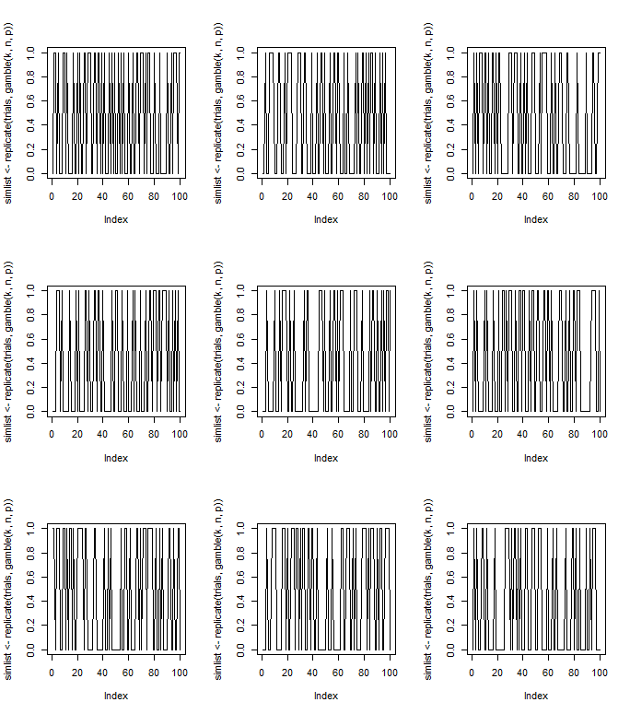

Producer of Mehrab Atighi

End.